Interactive Business Analytics Dashboard Using Power BI
BY: DIVYASRI.A
1.Business Scenario / Background :
A company manages a dataset of 50,000 CEO and employee records. Analyzing such a large amount of data manually is difficult and time-consuming. The Interactive Business Analytics Dashboard Using Power BI helps visualize key business metrics, track performance, identify trends, and support data-driven decision-making through interactive reports and dashboards.

2.Business Objectives
- Analyze Large-Scale Data – Efficiently analyze 50,000 CEO and employee records to gain meaningful business insights.
- Monitor Key Performance Indicators (KPIs) – Track metrics such as employee performance, department productivity, salary distribution, and business growth.
- Support Data-Driven Decisions – Provide interactive dashboards and reports that help management make informed strategic decisions.
- Improve Reporting Efficiency – Reduce manual reporting efforts by automating data visualization and analysis.

3.Key KPIs for Interactive Business Analytics Dashboard (CEO Dataset)
- Total Employees
- Average Salary
- CEO Salary
- Employee Performance Score
- Department-wise Employee Count
- Bounce Rate
- Demo Conversion Rate
- Industry-wise Contacts
- Country-wise Contacts
- Annual Revenue
- Company Size Distribution (Employee Count)

4. Dataset Overview
- 50,000 business contact records
- Contact details – Name, Email, Phone
- Professional details – Job Title, Role, Seniority, Department
- Company information – Company Name, Industry, Employee Count
- Location details – City, State, Country
- Financial data – Annual Revenue
- Engagement metrics – Email Open, Reply, Bounce, Demo Status
- Used for business analytics, sales performance, and customer engagement analysis in Power BI.

Data Cleaning & Preparation
- Removed duplicate records, handled missing values, and standardized data formats to improve data quality.
- Cleaned and transformed the dataset to ensure accurate analysis and effective dashboard performance in Power BI.

5. Business Questions
How many total contacts and companies are there?

Which industries have the most contacts?

Which countries have the highest number of contacts?

What is the distribution of contacts by department and seniority?

6 . EDA (Exploratory Data Analysis) Summary
- Analyzed the distribution of contacts across industries, departments, and locations.
- Identified trends in email engagement, company size, and annual revenue.
- Detected missing values, duplicates, and data patterns to improve data quality.
- Generated insights to support dashboard creation and business decision-making.

7.Key Insights
- A few industries contribute the highest number of business contacts.
- Email open rates are higher than reply and demo conversion rates.
- Large companies with higher employee counts generate more business opportunities.
- Certain countries and regions have a higher concentration of potential leads.
- Senior-level contacts play a significant role in business engagement and conversions.

8.Recommendations
- Focus outreach efforts on high-performing industries and regions.
- Improve email campaigns to increase reply and demo conversion rates.
- Target senior-level decision-makers for better engagement.
- Prioritize companies with high employee counts and annual revenue.
- Regularly monitor KPIs through the Power BI dashboard to support data-driven decisions.

9.Visualization:
- Country-wise Contact Distribution
Chart Type: Horizontal Bar Chart
Description:
- Displays the country-wise distribution of business contacts, helping identify the most important markets and business opportunities.
- Compares the number of records available from each country.

- Helps identify regions with the highest concentration of business contacts.

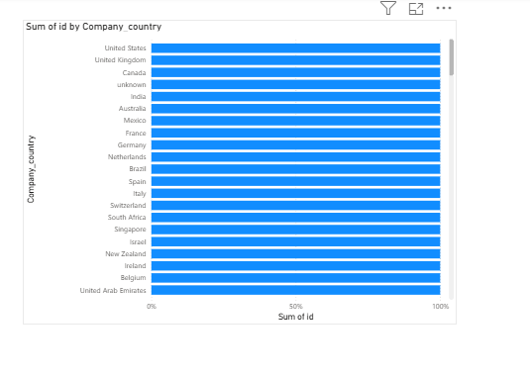
- . Bar Chart (Company and Country Analysis)

Description:
- Compares records across companies and countries.
- Identifies top-performing companies.
- Supports market analysis.

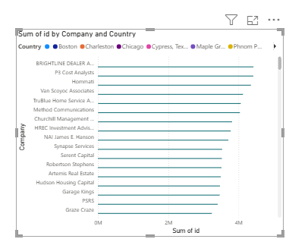

3.Pie Chart (Company-wise Distribution)
Description:
- Shows the percentage share of records by company.
- Identifies major contributing companies.
- Highlights company distribution.
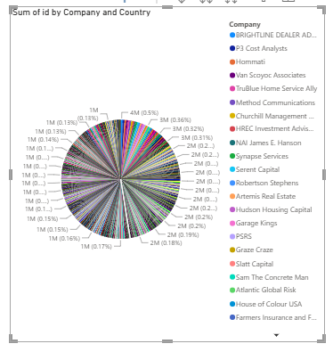

4. Line Chart (Employees and Email Bounce Analysis)
- Shows trends in employee records and email bounces.
- Identifies fluctuations in engagement data.
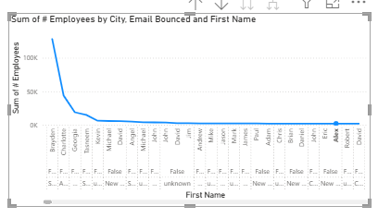
- Helps evaluate email campaign effectiveness.

5.Gauge Chart (Annual Revenue KPI)
Description:
- Shows overall annual revenue performance.
- Compares actual revenue with the target.
- Helps monitor business growth.
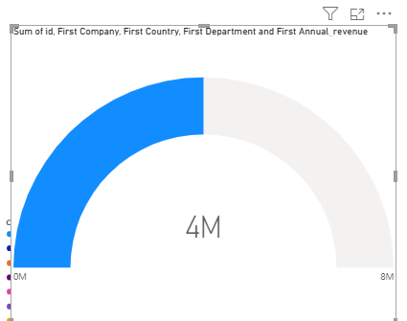

6.Stacked Column Chart (Employees by City and Department)
Description:
- Displays employee distribution by city.
- Shows department-wise workforce allocation.
- Helps analyze regional workforce trends.

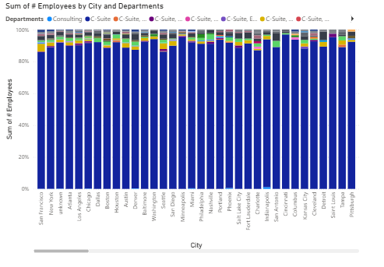
7.Waterfall Chart (Employees by Apollo Contact ID and Annual Revenue)
- Shows the cumulative impact of annual revenue across different Apollo Contact IDs.
- Highlights increases and decreases in employee-related business metrics.
- Helps identify contacts contributing most to overall revenue performance.
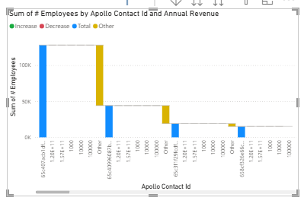

10.Conclusion:

The Interactive Business Analytics Dashboard using Power BI successfully transformed 50,000 business records into meaningful insights.

The dashboard enabled effective analysis of contacts, companies, revenue, and email engagement metrics through interactive visualizations.

It supports data-driven decision-making, improves business performance, and helps identify growth opportunities.



